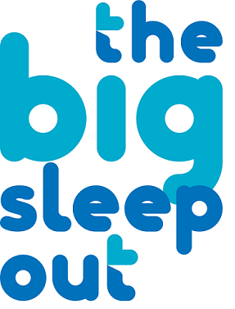
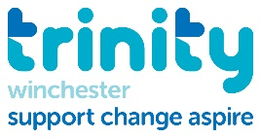
Big Sleep Out Registration Form

Name _______________________________________
Email _______________________________________
Address_______________________________________________________________________________________________________________________________________________________________________________________________________________________________________________
Would you prefer to receive your fundraising pack by Post / Email? (please circle one)
Do you have any dietary requirements? __________________________________________
Payment
Registration Fee £12 per person. Teams of 6+ £55
I would like to book ___ places for the Big Sleep Out.
I enclose a cheque for £_______ / I enclose cash to the sum of £____
If you are registering a team and know the details of your teammates, please complete here:
Team Name:

Name | Contact Email / Number | Under 18? (If so, please provide age. We will require a signed consent form from parent / guardian before the event) | Dietary Requirements

By signing up to take part in this event, you understand that Trinity, its employees and volunteers cannot be held responsible for any personal injury, accident, loss, damage or public liability. You accept that any photos taken during the event may be used for promotional purposes unless you request otherwise. This is a fundraising event and by registering to take part, we ask people to aim to raise £100 in sponsorship.

Signed ____________________________________________________________

