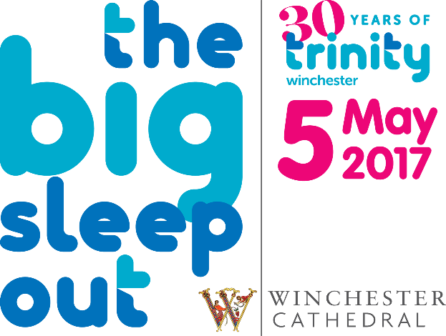
Sponsorship Form
Name E-Mail
Address Postcode
I am happy for Trinity Winchester to keep me updated of future events via e-mail

I am taking part in The Big Sleep Out on Friday 5th May 2017 to raise money for Trinity Winchester. Please give generously!

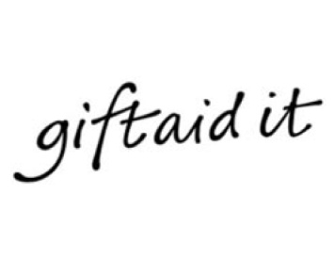
If I have ticked the box headed ‘Gift Aid? √’, I confirm that I am a UK Income or Capital Gains taxpayer. I have read this statement and want the charity or Community Amateur Sports Club (CASC) named above to reclaim tax on the donation detailed below, given on the date shown. I understand that if I pay less Income Tax / or Capital Gains tax in the current tax year than the amount of Gift Aid claimed on all of my donations it is my responsibility to pay any difference. I understand the charity will reclaim 25p of tax on every £1 that I have given.

Full name (First name and surname) | Home address (Only needed if you are Gift Aiding your donation, Please don't put your work address here) | Postcode | Amount £ | Date paid | Gift Aid?  √
Full name (First name and surname) | Home address (Only needed if you are Gift Aiding your donation, Please don't put your work address here) | Postcode | Amount £ | Date paid | Gift Aid?  √
For office use: Total donations received |  |  | £
Total Gift Aid donations |  |  | £
Date donations given to Charity or CASC
Please do photocopy this sheet or download another form from the website should you require additional forms.

