Trinity’s Big Sleep Out 2024
F.A.Q’s

How do I get there?
This year the event will take place in the grounds of Winchester College. To get there please use the following postcode (SO23 9NG) and refer to the map below for directions.
Key Red – from Winchester Cathedral (5min walk).
Yellow – from Bridge Street (if driving).
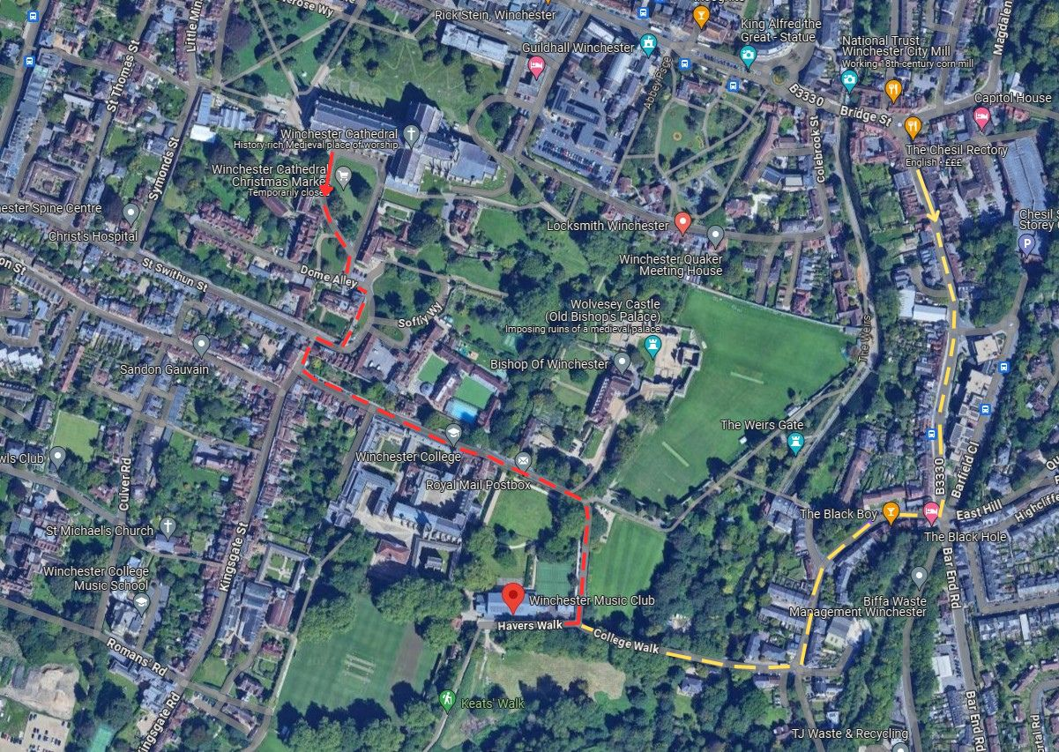

Is there parking available?
There is no parking available at the College, and limited spaces along College Walk. The safest bet is to park at Chesil St Multi Storey Car Park, (SO23 0HU) from there it is a 5-8min walk to Winchester College (SO23 9NG). This car park is also free after 6pm.

Do I need to bring my own cardboard?
We will supply cardboard, courtesy of Draper Tools. Feel free to bring some extra along if you can (especially if you want to go all out with your build!).

What essentials should I bring?
Each participant will receive a goody bag, this will include items such as, a blow-up cushion, hand sanitiser, wet wipes. We suggest you bring along things such as - a sleeping bag, blanket, roll/yoga mat, ground sheet, torch, charging packs (for your phone), warm clothing, tarpaulin (if it’s a bit drizzly to keep your shelter dry). Sellotape/decorations for your shelter.

What happens if it rains?
We have a wet-weather plan in place. Music will move to New Hall (by the entrance) and sleepers will stay overnight in New Hall. All food and activities will take place under marquees.

Will the event be cash only?
There will be card machines available, please do also bring cash if you can.

How do I set up my fundraising page?
Visit our campaign page www.justgiving.com/campaign/bso24 click the orange button ‘Start fundraising’ and follow the on-screen instructions.
A paper version is also available – please email kirsty@trinitywinchester.org.uk

What happens if I do not reach the £100 target in sponsorship?
The target is simply something to aim for, do not worry if you have not reached it.

Can people take part in the event but not sleep out?
Of course! Non-sleepers are very welcome, they will depart from the venue by 11pm.

Will there be food and drink available?
Yes, food will be provided by Piecaramba, BBQ from the Hursley Butcher and our very own Trinity stall providing sausage rolls, quiches, and salads.
The sweetie stall will also have cakes, tea, coffee and soft drinks.

Will there be on-site toilets?
Male and female toilets are available.

Will there be water available?
Water will be available from the College (New Hall) until 8pm. We also have ample bottled water available.

Will there be a first aider on-site?
Yes, we will have a qualified first aider and pediatric first aider on site throughout the event (Friday 6pm – Saturday 8am).

Will the area be secured after 11pm?
Yes, by 11pm all non-sleepers will have left, and the area will be secured (gates locked). There will be two security people, two Trinity reps and a Winchester College steward awake overnight to ensure that everyone remains safe and well.

Will there be breakfast available?
Yes! We are very grateful that Rapid Relief Team www.rrtglobal.org/gb/ will once again return to support our event. They will supply breakfast, plus tea and coffee free of charge! Breakfast will be served at 7am.

For any other questions please contact kirsty@trinitywinchester.org.uk

